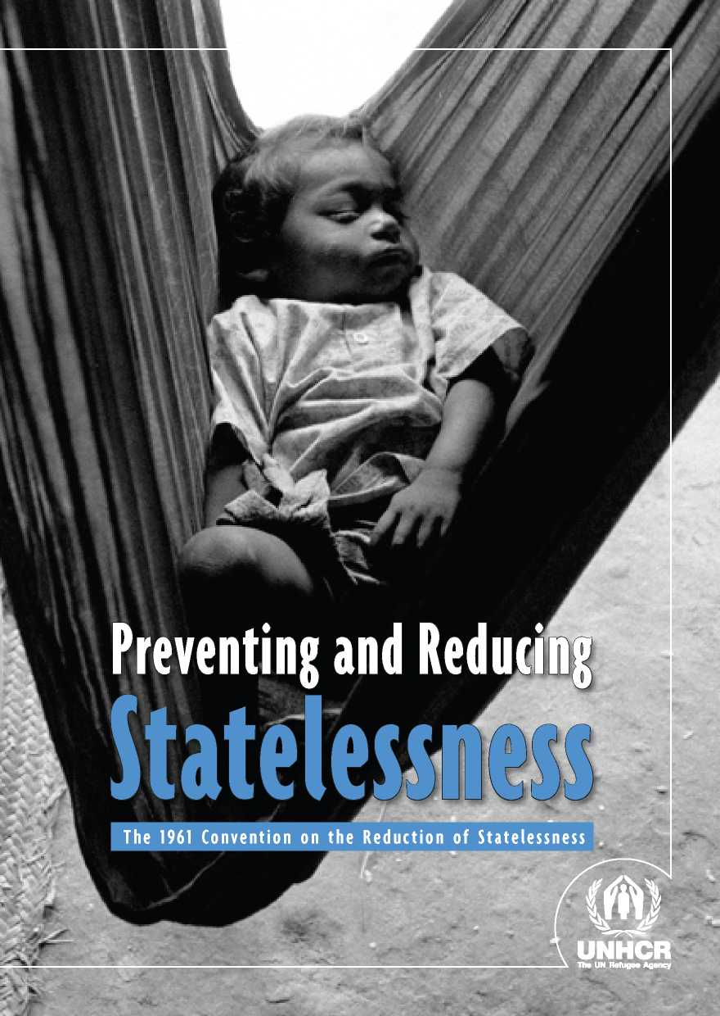

A PERSONAL APPEAL

FROM THE UNITED NATIONS HIGH COMMISSIONER FOR REFUGEES

Millions of people around the world are stateless. This is a matter of grave concern. The Convention on the Reduc­tion of Statelessness is an important tool for tackling the problem. Many States already have legislation that is compliant with the provisions of the Convention and implementing it costs very little. Yet few States are parties to this instrument. We need to change that. I pledge the full support of my Office to governments wishing to become parties.

Antonio Guterres

PROMOTING THE RIGHT  
TO A NATIONALITY

N

ationality is a legal bond between a person and a State. Nationality provides people with a sense of identity but, more importantly, enables them to exercise a wide range of rights. The lack of any nationality, statelessness, can therefore be harmful, in some cases devastating to the lives of the individuals concerned.

Article 15 of the Universal Declaration of Human Rights affirms that “everyone has the right to a nationality”. With these words, the international community recognized that every individual, everywhere in the world, should hold a legal bond of nationality with a State. In other words, international law says clearly that statelessness should be avoided.

Despite this firm international commitment, new cases of statelessness have continued to arise. Tackling statelessness still poses a major challenge in the 21st century. There are at least 10 million stateless people around the world today.

States are responsible for conferring nationality. Each State lays down the criteria for conferral and withdrawal of nationality in its own domestic law. It is, there­fore, States which must take action, alone and in cooperation with other States, to ensure that everyone has a nationality. Although the Universal Declaration of Human Rights confirms that everyone has the right to a nationality, it does not set out the specific nationality to which a person is entitled. This absence of clear rules may result in statelessness. States therefore developed a series of ad­ditional standards, which were adopted in 1961 in the form of the Convention on the Reduction of Statelessness (“1961 Convention”), in recognition of the need for further international cooperation and agreement to prevent and reduce statelessness.

A growing number of States are turning to the 1961 Convention for guidance on how to meet their international obligation to prevent statelessness. While the 1961 Convention had only 37 States Parties on 1 January 2011, 33 states pledged to accede to the Convention at the Ministerial Event organized by UNHCR in December 2011. By the end of January 2014 the number of State Parties had increased to 55. However, the influence of the Convention's provisions is far wider because many States have drawn elements of the Convention for inclu­sion in their nationality legislation.

WHY IS NATIONALITY IMPORTANT?

N

ationality provides people with a sense of identity and is key to full par­ticipation in society. Without a nationality, people are generally excluded from political processes because they do not have the right to vote. Moreover, only ‘citizens' have the unrestricted right to enter and reside in a country under international law. Stateless persons may therefore end up without any residence status or, worse, in prolonged detention. Statelessness also causes dif­ficulties in a wide range of other areas, from travel to access to education and healthcare. Statelessness prevents people from fulfilling their potential and may have severe knock-on effects for social cohesion and stability; it may even lead to communal tension and displacement. Preventing and reducing statelessness is an effective way to tackle one root cause of such problems.

UNHCR/G. CONSTANTINE

WHY IS THE 1961 CONVENTION  
RELEVANT TODAY?

A

lthough it has long been understood that statelessness should be avoided and that this goal can only be achieved through international cooperation, many States have yet to take action to ensure that everyone enjoys the right to a nationality. Due to the differing approaches taken by States with regard to the acquisition and loss of nationality, some individuals continue to “fall through the cracks” and become stateless. Common rules are therefore essential to address such gaps. The 1961 Convention is the only universal instrument that elaborates clear, detailed and concrete safeguards to ensure a fair and appropriate response to the threat of statelessness. Accession to the 1961 Convention equips States to avoid and resolve nationality-related disputes and mobilize international support to adequately deal with the prevention and reduction of statelessness. A higher number of States Parties will also help to improve international relations and stability by consolidating a system of common rules.



A map drawn on the wall of a home in Cote d'Ivoire gives a sense of the population movements between neighbouring countries and Cote d'Ivoire before and after independence. Conflicts between the nationality laws of States can lead to statelessness. This is more likely to occur when people live outside of the country of their nationality or have children abroad. These problems can be addressed by introducing safeguards in nationality laws such as those stipulated in the 1961 Convention. Birth registration and issuance of documentation are also essential because they document the links every person has to one or more States.

HOW THE 1961 CONVENTION HELPS  
TO AVOID STATELESSNESS

WHEN DOES THE 1961 CONVENTION APPLY?

T

he 1961 Convention sets out rules for the conferral or non-withdrawal of nationality *only* where the person in question would be left stateless. In other words, the provisions of the 1961 Convention offer carefully detailed safeguards against statelessness that should be implemented through a State's nationality law, without specifying any further parameters of that law. Beyond these few, simple safeguards, States are free to elaborate the content of their nationality legislation. However, these rules must be consistent with other international standards relating to nationality.

HOW CAN THE 1961 CONVENTION ASSIST STATES IN REDUCING STATELESSNESS?

B

y applying the safeguards elaborated in the 1961 Convention wherever a person would be left stateless, States can *prevent* new cases of statelessness from arising. The 1961 Convention's provisions are, however, equally relevant to the task of *reducing* statelessness. It does this in two ways. First, prevention of statelessness leads to a reduction of statelessness over time. Second, when bringing their domestic legislation into line with the safeguards detailed in the 1961 Convention in order to prevent future statelessness, States are encour­aged to also use this opportunity to *reduce* statelessness. For example, States may apply newly introduced safeguards retroactively and accordingly allow for acquisition of nationality by stateless people.

WHAT DOES THE 1961 CONVENTION ASK STATES TO DO?

T

here are four main areas in which the 1961 Convention on the Reduction of Statelessness provides concrete and detailed safeguards to be imple­mented by States in order to prevent and reduce statelessness. UNHCR can offer technical support to help States ensure that these safeguards are reflected in their nationality legislation and practice.

**> Measures to avoid statelessness among children**

Articles 1 to 4 principally concern the acquisition of nationality by children. States shall grant their nationality to children who would otherwise be stateless and have ties with them through either *birth in the territory* or *descent*. As a result, where children are born in the territory but acquire the nationality of a foreign parent, there is no obligation to grant nationality. Nationality shall either be granted at birth, by operation of law, or upon application. The 1961 Convention permits States to make the conferral of nationality subject to certain conditions, such as habitual residence for a certain period of time. Under Article 2, States shall grant nationality to foundlings (children found on the territory).

**> Measures to avoid statelessness due to loss or renunciation of nationality**

Articles 5 to 7 prevent statelessness in later life by requiring prior possession or assurance of acquiring another nationality before a nationality can be lost or renounced. Two exceptions to this rule are provided for: States may withdraw nationality from naturalized persons who subsequently take up long-term resi­dence abroad for more than seven consecutive years and from nationals who were born abroad and are not resident in the State when they attain majority, provided certain other conditions are met.

* **Measures to avoid statelessness due to deprivation of nationality**

Articles 8 and 9 of the 1961 Convention deal with the deprivation of nation­ality. States may not deprive any person of their nationality on racial, ethnic, religious or political grounds. Deprivation of nationality that results in state­lessness is also prohibited, except where the individual obtained nationality by misrepresentation or fraud. States may retain the right to deprive a person of his or her nationality even if this leads to statelessness where he or she has committed acts inconsistent with the duty of loyalty to the State or has made an oath or formal declaration of allegiance to another State. In deciding whether to deprive an individual of his or her nationality, the State should consider the proportionality of this measure, taking into account the full circumstances of the case. Due process guarantees need to be respected throughout the procedure regarding deprivation.

* **Measures to avoid statelessness in the context of State succession**

State succession, such as the cession of territory by one State to another and the creation of new States, can lead to statelessness unless proper safeguards are in place. Avoidance of statelessness in such cases is essential to promoting social inclusion and stability. Article 10 addresses the specific context of State succession and asks States to include provisions to ensure the prevention of statelessness in any treaty dealing with the transfer of territory. When no treaty is concluded, the State(s) involved shall confer its/their nationality on those who would otherwise be stateless as a result of the transfer of territory.

DOES THE 1961 CONVENTION REQUIRE STATES TO ADOPT THE *JUS SOLI* DOCTRINE?

N

o. The 1961 Convention does not compel States to confer nationality to all children born on their soil (*jus soli* doctrine) or to all children born to one of their nationals (*jus sanguinis* doctrine). It recognises the legitimacy of both birthplace and descent as criteria for acquisition of nationality at birth. The Convention therefore contains safeguards to avoid statelessness based on both doctrines. Where a child would otherwise be stateless and has a link based on birth on the territory or to a national, the 1961 Convention requires States Parties to grant nationality. Such conferral of nationality may be made subject to a number of additional conditions.

IS THE 1961 CONVENTION THE ONLY INSTRUMENT RELEVANT TO THE PREVENTION AND REDUCTION OF STATELESSNESS?

N

o. Many other international legal instruments, such as the Universal Declaration of Human Rights, recognize the right to a nationality and have an impact on how States should deal with the prevention and reduction of statelessness. Examples include:

* Convention on the Elimination of All Forms of Racial Discrimination which obliges States to guarantee the enjoyment of the right to a nationality with­out distinction as to race, colour or national or ethnic origin;
* Convention on the Rights of the Child which affirms the right of every child to acquire a nationality;
* Convention on the Elimination of All Forms of Discrimination Against Women which requires equality between men and women in respect of acquisition, change and retention of nationality and the transmission of nationality to children.

In addition, the 1954 Convention relating to the Status of Stateless Persons, besides providing for special protective measures for stateless persons, calls upon States to facilitate naturalization in the context of resolving statelessness.

There are also relevant regional standards helping to prevent and reduce state­lessness such as Article 6 of the African Charter on the Rights and Welfare of the Child, Article 20 of the American Convention on Human Rights, Article 7 of the Covenant on the Rights of the Child in Islam and a series of provi­sions in the European Convention on Nationality. Many States have therefore already taken on important international obligations for the promotion of the right to a nationality. These obligations are complementary to those in the 1961 Convention. However, the 1961 Convention remains the only instrument offer­ing common universal safeguards for the avoidance of statelessness. It thereby addresses nationality problems which may occur within a specific region but also those problems which require application of common rules by States in different regions.

HOW UNHCR ASSISTS STATES  
TO AVOID STATELESSNESS

T

he UN General Assembly selected UNHCR for the task of assisting States to avoid statelessness not only because refugee and statelessness problems sometimes overlap, but also because dealing with statelessness requires, in many ways, a similar approach to dealing with refugees. Both populations lack protection.

UNHCR helps States to implement the 1961 Convention on the Reduction of Statelessness by offering technical advice regarding legislation and operational support to promote the implementation of measures to prevent and reduce statelessness. UNHCR's global mandate on statelessness is reinforced by a spe­cific duty conferred by Article 11 of the 1961 Convention: to assist individuals who may benefit from the instrument's provisions in presenting their claim to the appropriate State authorities.

THE LINK WITH THE 1954 CONVENTION  
RELATING TO THE STATUS  
OF STATELESS PERSONS

E

ven if they have acceded to and implemented the 1961 Convention on the

Reduction of Statelessness and other international legal standards relating to the prevention and reduction of statelessness, States may still be confronted with stateless individuals or groups. It is therefore vital that there are measures in place to ensure the protection of stateless persons. The 1954 Convention relating to the Status of Stateless Persons is the primary international instru­ment that aims to regulate and improve the status of stateless persons and to ensure that they are accorded their fundamental rights and freedoms without discrimination. Acceding to *both* the 1954 and 1961 Statelessness Conventions is a key step to equip States to tackle statelessness**.** More detailed information about the 1954 Convention can be found in *Protecting the Rights of Stateless Persons - The 1954 Convention relating to the Status of Stateless Persons* (UNHCR, 2014).

THE IMPORTANCE OF ACCESSION  
TO THE 1961 CONVENTION

Acceding to the 1961 Convention on the Reduction of Statelessness:

**•** Is a way for States to demonstrate their commitment to human rights and humanitarian standards, including the right to a nationality

**•** Enables States to address gaps that result from different approaches to the attribution of nationality worldwide through the recognition of common safeguards for the avoidance of statelessness, without impinging on States' sovereignty to regulate nationality

**•** Boosts legal transparency and predictability in States' response to the threat of statelessness through the promotion of common safeguards

**•** Provides States with the tools to avoid and resolve nationality-related dis­putes, thereby also improving international relations and stability

**•** Prevents displacement by promoting the enjoyment of the right to a nationality

**•** Enhances national security and stability by avoiding exclusion and mar­ginalisation resulting from statelessness

**•** Promotes enfranchisement and the full participation of individuals in society

**•** Helps UNHCR to mobilise international support for the prevention and reduction of statelessness

FREQUENTLY ASKED QUESTIONS  
ABOUT ACCESSION

QUESTIONS

ANSWERS

Here are answers to some of the most frequently asked questions about accession to the 1961 Convention on the Reduction of Statelessness. Further questions and details are discussed in *Nationality and Statelessness: A Handbook for Parliamentarians* (UNHCR and Inter-Parliamentary Union, 2005, revised second edition forthcoming in 2014).

n **Is the 1961 Convention relevant for States that have safeguards for avoiding statelessness in place?**

Many States have already adopted safeguards in their nationality legislation in order to avoid statelessness. Even if this is the case, acceding to the 1961 Convention remains a valuable step in tackling statelessness. It lets other countries know that such safeguards are recognised by the State in question and it helps to promote worldwide acceptance of these common international standards.

n **Does the 1961 Convention compel States to allow dual nationality?**

No. States may continue to prohibit dual nationality, as long as the laws and practices relating to the avoidance of dual nationality do not lead to statelessness. For example, a State may still require an individual to renounce their former nationality upon naturalization in order to avoid dual nationality. However, a State may not allow a person to renounce their nationality before they have gained possession or assurance of acquiring another nationality.

n **Does the 1961 Convention prohibit any withdrawal of nationality?**

No. The loss or deprivation of nationality is only prohibited under the terms of the

1961 Convention where this would result in statelessness. Moreover, as explained above, States may still allow for the loss or deprivation of nationality even if this leads to statelessness, in a limited number of circumstances and in accordance with the further conditions outlined in Articles 7 and 8 of the Convention.

n **Can a State adopt reservations to the provisions of the 1961 Convention?**

Yes. Reservations are permitted at the time of accession, but only concerning Article 11 (UNHCR's role), 14 (referral of disputes to the International Court of Justice) or 15 (territories for which the Contracting State is responsible). In accordance with Article 8, States can also adopt a declaration at the time of accession whereby they retain the right to deprive a person of his or her nationality in certain limited circumstances.

n **What considerations are involved in acceding to the 1961 Convention? Are there costs or reporting requirements?**

Acceding to the 1961 Convention implies a commitment to ensure that specific safeguards are reflected in relevant domestic legislation. This may mean adopting modifications to nationality laws - a task for which UNHCR can provide technical assistance. Thereafter, implementation of

the 1961 Convention is neither costly nor labour intensive: for the most part the safeguards are applied automatically, just like many other provisions of nationality laws. No expensive procedures or institutions are required. The 1961 Convention does not prescribe any formal reporting obligations for States Parties. However, making information on nationality laws available to other States and UNHCR is an important means of ensuring that the safeguards are implemented correctly by all States Parties.n How does a State accede to the 1961 Convention?

This woman is a former Soviet citizen who came to Ukraine from the Southern Caucasus. She had no valid documents but later was found to be a citizen of Georgia and obtained a passport. Prevention of statelessness often requires examining whether a person falls under nationality laws of one or more countries. Arrangements need to be in place to protect the rights of the individual until such time as their nationality can be confirmed, or if they are found to be stateless.

States may accede to the 1961 Convention at any time by depositing an instrument of accession with the Secretary-General of the United Nations. The instrument of accession must be signed by the Foreign Minister or the Head of State or Government. Further details on accession procedures and model instruments of accession can be found at [www.unhcr.org/statelessness](http://www.unhcr.org/statelessness).

INTERNATIONAL CALLS FOR ACCESSION

**UN General Assembly:** *Welcomes* pledges by States to accede to the statelessness conventions, the 1954 Convention relating to the Status of Stateless Persons and the 1961 Convention on the Reduction of Statelessness, as well as pledges to remove reservations to them, also welcomes the recent increase in the number of accessions to the two Conventions [...]

* *General Assembly Resolution 67/149, Office of the United Nations High Commissioner for Refugees, 20 December 2012*

**UN Human Rights Council:** *Acknowledges* that 2011 will mark the fiftieth anni­versary of the Convention on the Reduction of Statelessness, and encourages States that have not acceded to the Convention and the Convention relating to the Status of Stateless Persons to consider doing so.

UNCHR/G. CONSTANTINE

* *Human Rights Council Resolution 13/02, Human rights and arbitrary deprivation of nationality, 24 March 2010*

**UNHCR Executive Committee:** *Encourages* States to give consideration to acceding to the 1961 Convention on the Reduction of Statelessness and, in regard to States Parties, to consider lifting reservations.

* *Conclusion No. 106 (LVII) - 2006*

**Asian-African Legal Consultative Organization:** *Invites* Member States to consider the possibility of acceding to the 1954 Convention relating to the Status of Stateless Persons and the 1961 Convention on the Reduction of Statelessness to address the plight of stateless persons in an effective way.

* *Resolution on the Half-Day Special Meeting on “Legal Identity and Statelessness”, 8 April 2006*

**General Assembly of the Organization of American States:** *Resolves* 1. To invite those member states that have not yet done so to consider ratifying or acceding to, as the case may be, the international instruments in the area of stateless persons, and to promote the adoption of procedures and institutional mechanisms for their application, in accordance with those instruments. 2. To emphasize the importance of the international instruments for the protection of stateless persons and for the prevention and reduction of statelessness, and to urge member states to follow up on the specific commitments entered into during the celebration of the 50th anniversary of the Convention on the Reduction of Statelessness, with technical support from the Office of the United Nations High Commission for Refugees (UNHCR).

* *Resolution of the General Assembly, AG/RES. 2787 (XLIII-O/13), Prevention and Reduc­tion of Statelessness and Protection of Stateless Persons in the Americas, 5 June 2013*

MODEL INSTRUMENT OF ACCESSION TO  
THE CONVENTION ON THE REDUCTION  
OF STATELESSNESS OF 1961

WHEREAS a Convention on the Reduction of Statelessness was adopted by the Conference of Plenipotentiaries on the thirtieth day of August, one thousand nine hundred and sixty-one, and is open for accession pursuant to Article 16 thereof;

AND WHEREAS, it is provided in section 4 of the said Article 16 that acces­sion thereto shall be affected by deposit of an instrument with the Secretary General of the United Nations;

NOW THEREFORE, the undersigned, [Title of Head of State, Head of Govern­ment or Foreign Minister] hereby notifies the accession of the [State concerned];

GIVEN under my hand in this day of two

thousand and .

[Public Seal and Signature of custodian if appropriate]

[Signature of Head of State, Head of Government or Foreign Minister]

**Cover:**

A Nepalese boy from the marginalised Dalit community rests next to his grandfather. Disadvantaged communities in Nepal have often faced multiple obstacles to citizenship and the exercise of associated rights. For many people around the world, statelessness begins at birth, often because the parents themselves are stateless. The 1961 Convention on the Reduction of Statelessness is designed to ensure that every child can acquire a nationality and that statelessness is not transmitted from one generation to another.

G. CONSTANTINE

I would like more information about:

**UNHCR and its work on statelessness**

Visit UNHCR's statelessness website at [www.unhcr.org/statelessness](http://www.unhcr.org/statelessness). You can also consult relevant Conclusions on International Protection of UNHCR's Executive Committee, in particular Conclusion 106 on Identification, Prevention and Reduction of Statelessness and Protection of Stateless Persons (2006).

**International law relating to the prevention and reduction of statelessness, including the 1961 Convention on the Reduction of Statelessness**

For a more detailed discussion of the 1961 Convention as well as other international norms relating to the protection of stateless persons, see *Nationality and Statelessness: A Handbook for Parliamentarians* (UNHCR and Inter-Parliamentary Union, 2005, revised second edition forthcoming in 2014) and *UNHCR Guidelines on Statelessness on Ensuring Every Child's Right to Acquire a Nationality through Articles 1-4 of the 1961 Convention on the Reduction of Statelessness.* To access these and other relevant international documents on statelessness, visit UNHCR's Refworld website at <http://www.refworld.org/statelessness.html>

**UNHCR**

The UN Refugee Agency

Published by:

UNHCR

P.O. Box 2500 1211 Geneva 2 Switzerland

UNHCR, January 2014



